**E-Government Scenario of Nepal and South Korea**

The introduction of e-governance in Nepal doesnot have a long history. E-governance is expected for supporting good governance initiatives of the government by enhancing efficiency and effectiveness; improving information dissemination and service delivery mechanisms through use of ICTs; and stimulating the development and growth of ICT sector within the country. To implement the e-governance initiative there is a need for infrastructure development, improvement of law and public policy, building e-literacy, enhance accessibility, ensure privacy and security, and development of workforce. In addition, there is a strong commitment from the leadership for the development and give attention for strategic investment, collaboration and citizen participation. One of the key functions of developing the e-governance is introducing IT Policy in 2000 in Nepal. The IT Policy specifies its broader objectives as:

* To make information technology accessible to the general public and increase employment through this means,
* To build a knowledge-based society, and
* To establish knowledge-based industries.

Effective application of ICTs in public administration and governance area in Nepal remains relatively low. Even though the trend to use personal computers (PCs) and networking has been increasing, there is conspicuous lack of systemic approach to deployment of ICTs based delivery models in the administrative set-up. In addition to governmental departments, academic institutions, private organizations and the NGOs have also increased significantly and coming up with web presence. In a way there is an overwhelming increment for using telephone and mobile phones. In 1999, the teledensity reached one line per 100 inhabitants which was 1.4% in 2003, and expected to 15% by 2017. It was the private sector that first connected Nepal to the internet in 1995. PC penetration in Nepal is continually on the rise and is at an estimated 0.96 per 100 people. The ISPs source reveals that the number of subscribers to their services has an annual increment of 50 percent. There were only 35,000 users in 2000 which has increased by ten times in 2009. These trend shows that there is a growing trend for the application of ICTs in Nepal. It is estimated that business organizations use 30 percent of internet services followed by international organizations based in Nepal and private home users by 20 percent each. The NGOs occupy 15 percent share, educational institutions 10 percent, and government entities just limited to only 5 percent. The following result was found in UN E-Government survey 2014 for Nepal:

* E-Government Development Index 0.3458 - Rank 135 of 193
* E-Participation Index 0.5085 - Rank 89 of 193

Although Nepal stands at the lower rung in the global scenario of ICT, there have been discernible developments in the ICT sector in the recent past. The telecommunication facilities have improved remarkably. The academic institutions/universities producing ICT professionals have expanded. The communication technologies, both electronic and print media, have extended their access to general people. Uses of the Internet, emails and computers are gaining in popularity. Telecenters are widening their outreach. Several e-Government applications are being introduced. Another milestone is the preparation of an ICT Development Project which has worked out detailed investment proposals for prioritized projects. The Government of Nepal is keen and committed to promote e-Government for implementation of various G2G, G2C and G2B projects defined under respective priority areas. But the road to e-Government is not easy and straight. There are no doubt ample opportunities for national development through e-Government promotion. There are also several hurdles, problems and challenges which must be overcomed for successful accomplishments of Nepal's e-Government vision.

The present e-Government situation has a lot of challenges. Some of the challenges are:

* Low level of political commitment to the implementation of services
* Very poor culture of technology. Literacy about the technology is also very limited in the government
* 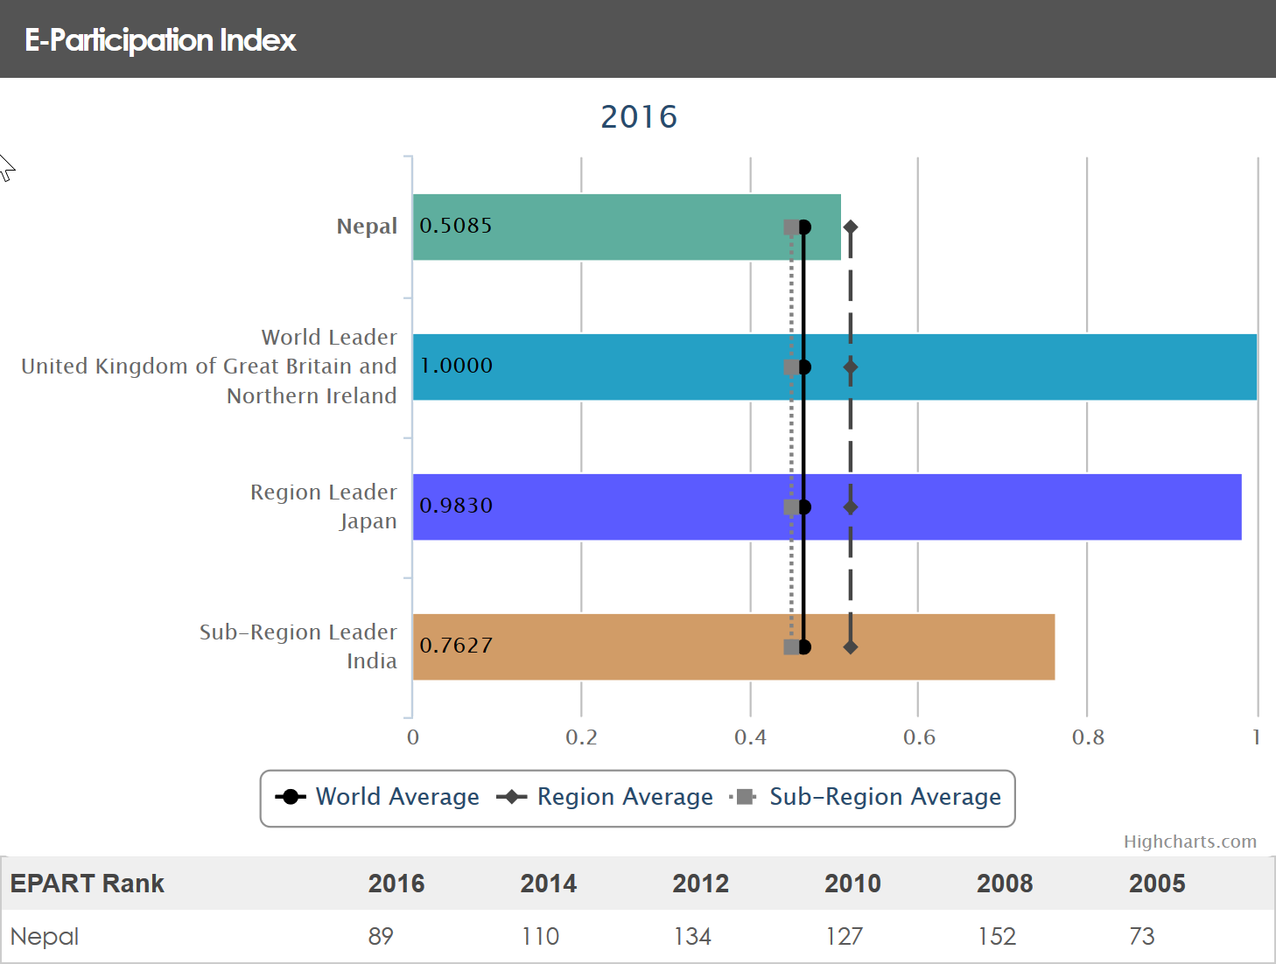The development of e-Government services is mostly skewed towards the major cities only. Usually, the new services provided by the government only penetrates the capital – Kathmandu.

Figure E-Participation Index for Nepal

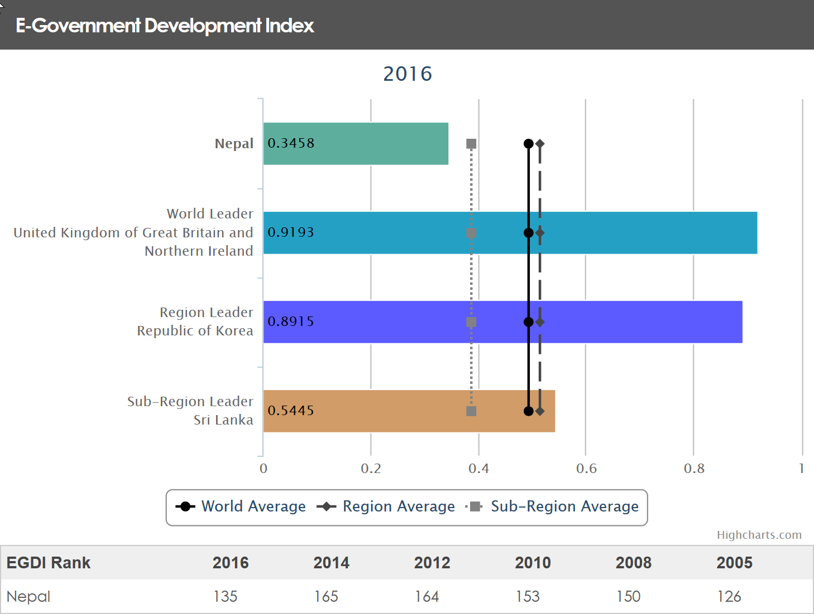

Figure E-Government Development Index for Nepal

E-government began in South Korea in the 1980s when the Ministry of Government Administration and Home Affairs (MOGAHA) began to implement ICT within government, based on the "National Backbone Computer Network" consisting of five national networks. After laying the groundwork for e-Government, including the National Basic Information System (NBIS) computer networks in the 1980s and streamlining of applicable laws and institutions in the 1990s, the Korean government made the implementation of e-Government a major national agenda for the 2000s. It has concentrated on 11 major tasks for e-Government (2001-2002) and 31 major tasks for the e-Government roadmap (2003-2007). As a result, e-Government has become firmly established in all areas of the Korean government.

The Korean e-Government has produced visible results: both efficiency and transparency of administrative work have been significantly improved; administrative civil services have been greatly enhanced; and opportunities for people to participate in the policy-making process have been expanded. Accordingly, the effectiveness of the e-Government of Korea is widely acknowledged by the international community and various e-Government systems are being exported to foreign countries. The 2010 UN Global E-Government Survey shows that Korea ranked first among all the member countries, given the highest possible scores in the categories of Online Service Index and the eParticipation Index. Also According to UN E-Government Survey 2016 Korea lies at third position in E-Government Development index with 0.8915 and fourth in E-participation index with 0.9661. Korea is now promoting e-Government that is focusing on utilization and convergence by consolidating services to maximize the convenience of users and implementing a seamless digital cooperation system connecting government departments and agencies, in order to improve the overall quality.

Korean e-Government is evaluated as one of the world’s best by the international community. Since 2003, the United Nations has provided comparative assessment reports on the e-Government development levels of its 192 member states, in order to facilitate and enhance global cooperation in and through e-Government and Korea ranked first in the 2010 UN Global E-Government Survey. The Korean e-Government was also evaluated as one of the world leaders in the third(transactional) or fourth(connected) stage of online services development by the UN. Many Korean e-Government systems have received awards and citations for best practices from international organizations.

Some of the achievements in E-government of South Korea are:

* Improvement of efficiency and transparency of administrative work.
* Provision of people and company-focused administrative services.
* Strengthening of communications with the people about government policies.
* Increased efficiency of information resource management.

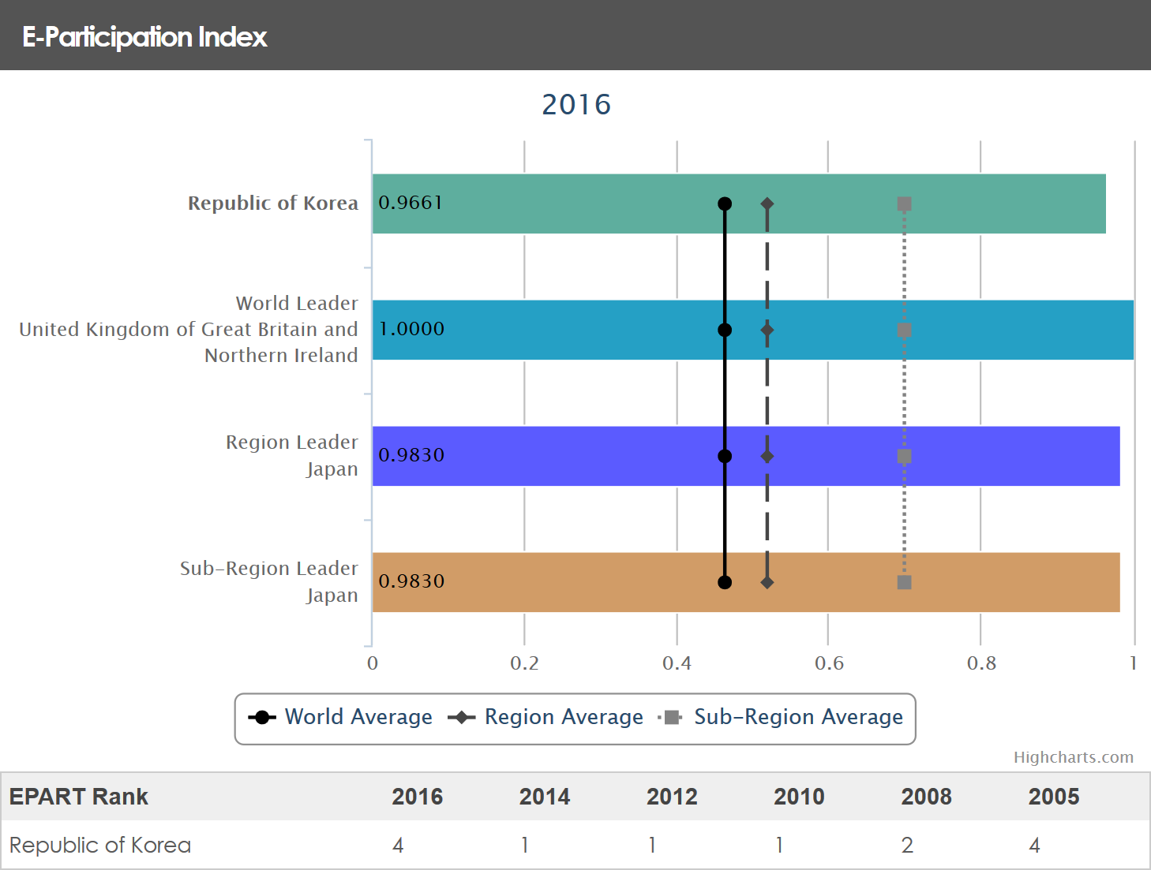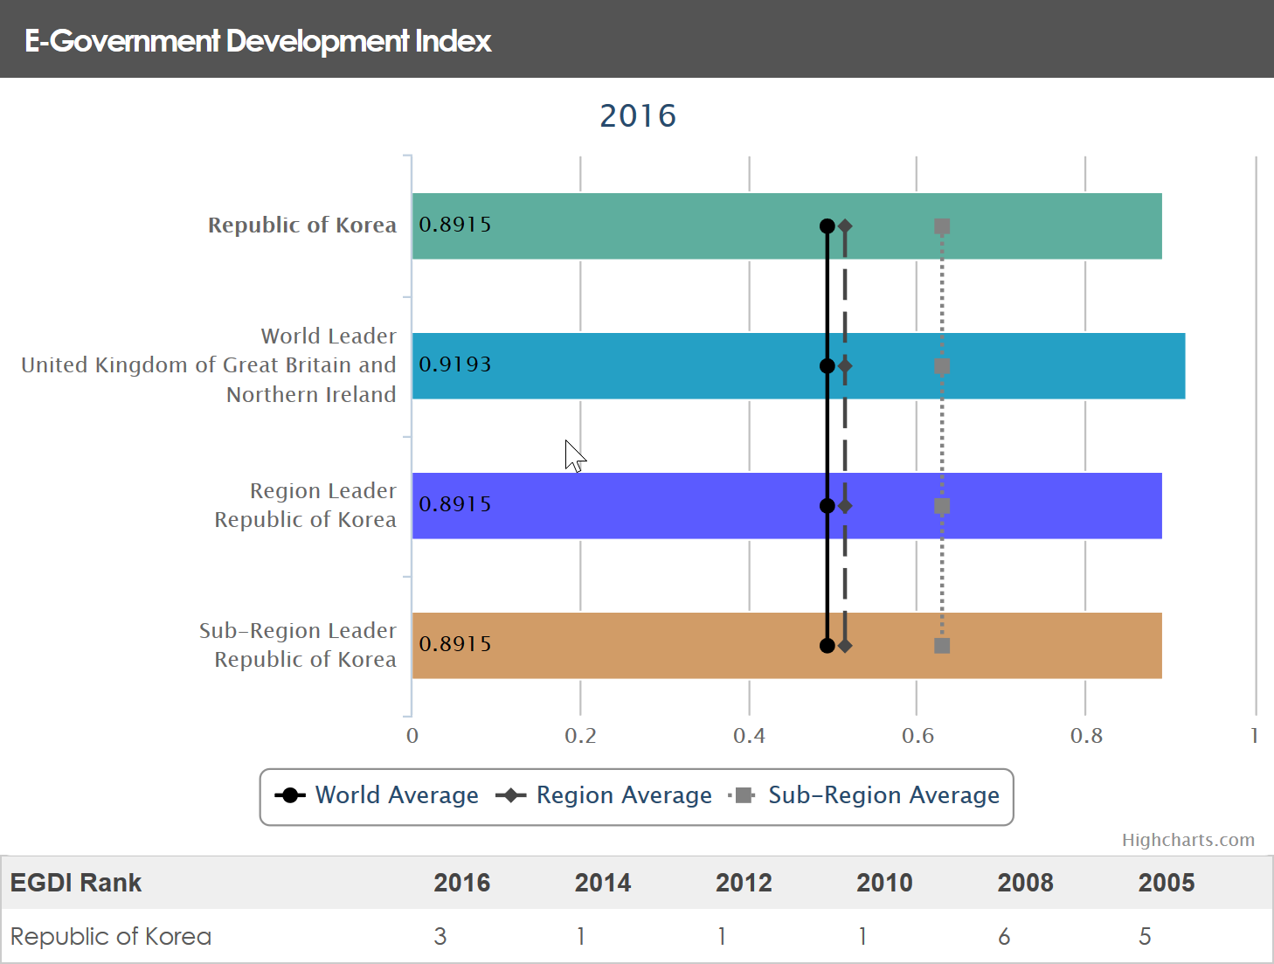

Figure E-Participation Index for Korea

Figure E-Government Development Index for Korea

Comparing the e-government scenario of Nepal and South Korea, we can say that Nepal is way back than the South Korea. It can be verified from the UN E-Government Development Survey of 2014. According to this Nepal is at 135 position in E-Government Development Index and at 89 position in E-Participation Index whereas South Korea lies among the top 5 countries in this index. Looking at the histiry of these two, they were somewhat similar in case of the E-Govewrnment development in 1990s. however the development of the E- government skyrocketed in Korea after these years. In comparision to Sou th Korea, Nepal has yet to achieve their heights and are still in the developing state of E-Governance.

